

CS 353 - Database Systems

Pure Digital Library

Group 4

Kaan Aktürk **-** 21401120

Pelin Elbin Günay - 21402149

Hareem Larik - 21503645

Emine Ayşe Sunar - 21502099

1. **Introduction:**

The following is a project proposal of a Scientific Paper Data Management System, called Pure Digital Library. The proposal consists of a description of the database system, its requirements, limitations, the entity relationship model of the database system and finally a conclusion.

The description discusses about the how and why the database is going to be used as a part of the system. Then, the requirements would be categorized into functional and non-functional requirements. The functional requirements are related to the users, editor, reviewers and the system and the non-functional requirements would be response time, capacity, user-friendliness, reliability, security, usability. Then a list of limitations of the project will be discussed. After that, the entity relation diagram will be provided for the conceptual design of the system. The proposal will end with a conclusion, summarizing the proposal. All the future updates of the project can be followed at:

<https://github.com/hlarik/CS353_Spring18>

**2. DESCRIPTION**

In our project, a scientific library database will be constructed. Our main aim is to offer users an enjoyable digital library service where social aspects are also added to a regular digital library. To succeed in it, a search bar that has various options to filter and sort the results will be available.

In the system, membership is required to access library data. Users must enter their name(s), surname, e-mail address, password and a unique username during the membership process. Username and the password must be entered before accessing the data. There will be different types of subscribes such as students, instructors, authors, reviewers and editors. Each of them will have different functionalities. For instance, during the membership process, in addition to features that are shown above, students and teachers must enter their institutions.

Moreover, some users can be the member of scientific journals. These users are considered as journal subscribers. To distinguish journal subscribers, subscription identity numbers are assigned to them.

All the users can make comment to papers and journals. These comments can be seen by only library members.

The papers, journals and comments can be rated by pressing the either like or dislike buttons. The rate will be shown at the bottom of them.

The sources are downloadable for members and their download count are also stored. This count also will be displayed to library members.

Pages of the papers are calculated. The number of clicks of each paper and journal is also counted when the users open them. Each user can increase only one time the read count in order to show proper statistic.

Users can search sources according to their titles, release year, author, institution(s) of the author and language. Users can also distinguish the sources by checking the conference that the source is submitted or published. Editors and reviewers that decide the publishment statue of the source will also be available to check the source. In addition to these options, results can be sorted according to like rate of the sources, their download count numbers, page number, comment number and click count.

**3.REQUIREMENTS  
3.1. Functional Requirement  
 3.1.1.User  
•** User should be able to login into the system with their name(s), surname, e-mail address, password and a unique username.  
• User should be able to search sources according to their titles, release year, author, institution(s) of the author and language.  
• User should be able to rate, like and comment on scientific papers and journals.  
• User should be able to rate comments by pressing the either like or dislike buttons.  
• User should be able to download resources   
• User should be able to see how many times the resource is downloaded.  
• User should be able to see how many pages the resource has.  
  
**3.1.2. Editors and reviewers   
  
•** Editors and reviewers should be able to decide whether the source will be published or not.   
 **3.1.3. System  
  
•** System should be able to sort the sources according to their like rates, their download count numbers, page number, comment number and click count.

**3.2 Non-Functional Requirements**

**3.2.1 User-friendly**

* The system will have a user-friendly interface in order to ease the users in searching their required articles.

**3.2.2 Response Time**

* The system will have an average response time of 5 seconds.

**3.2.3 Capacity**

* The database will support a large capacity to store a large number of scientific papers and users and their data.

**3.2.4 Security**

* The system will require all users to have their own personal accounts, and ask for authentication for login into their accounts, in order provide subscribers to their subscribed journals, accordingly.

**3.2.5 Reliability**

* The system will be up and running 24/7 daily, to provide reliable service to its users.

**3.2.6 Usability**

* User can easily learn to operate, access, and filter and sort the searches. There will be online help pages and manuals available.

**3.3 CONSTRAINTS**

* We will be using PHP and JavaScript for development
* MySQL will be used as our DBM system

**4. LIMITATIONS**

* Every user has a unique username
* User can like an article only once
* User can rate a post only once
* Read count of an article only increments from the first view from a user.
* Every author has to be associated with an institution
* User can only add a single comment for an article
* A comment can only be 5000 characters

**5. E/R DIAGRAM**

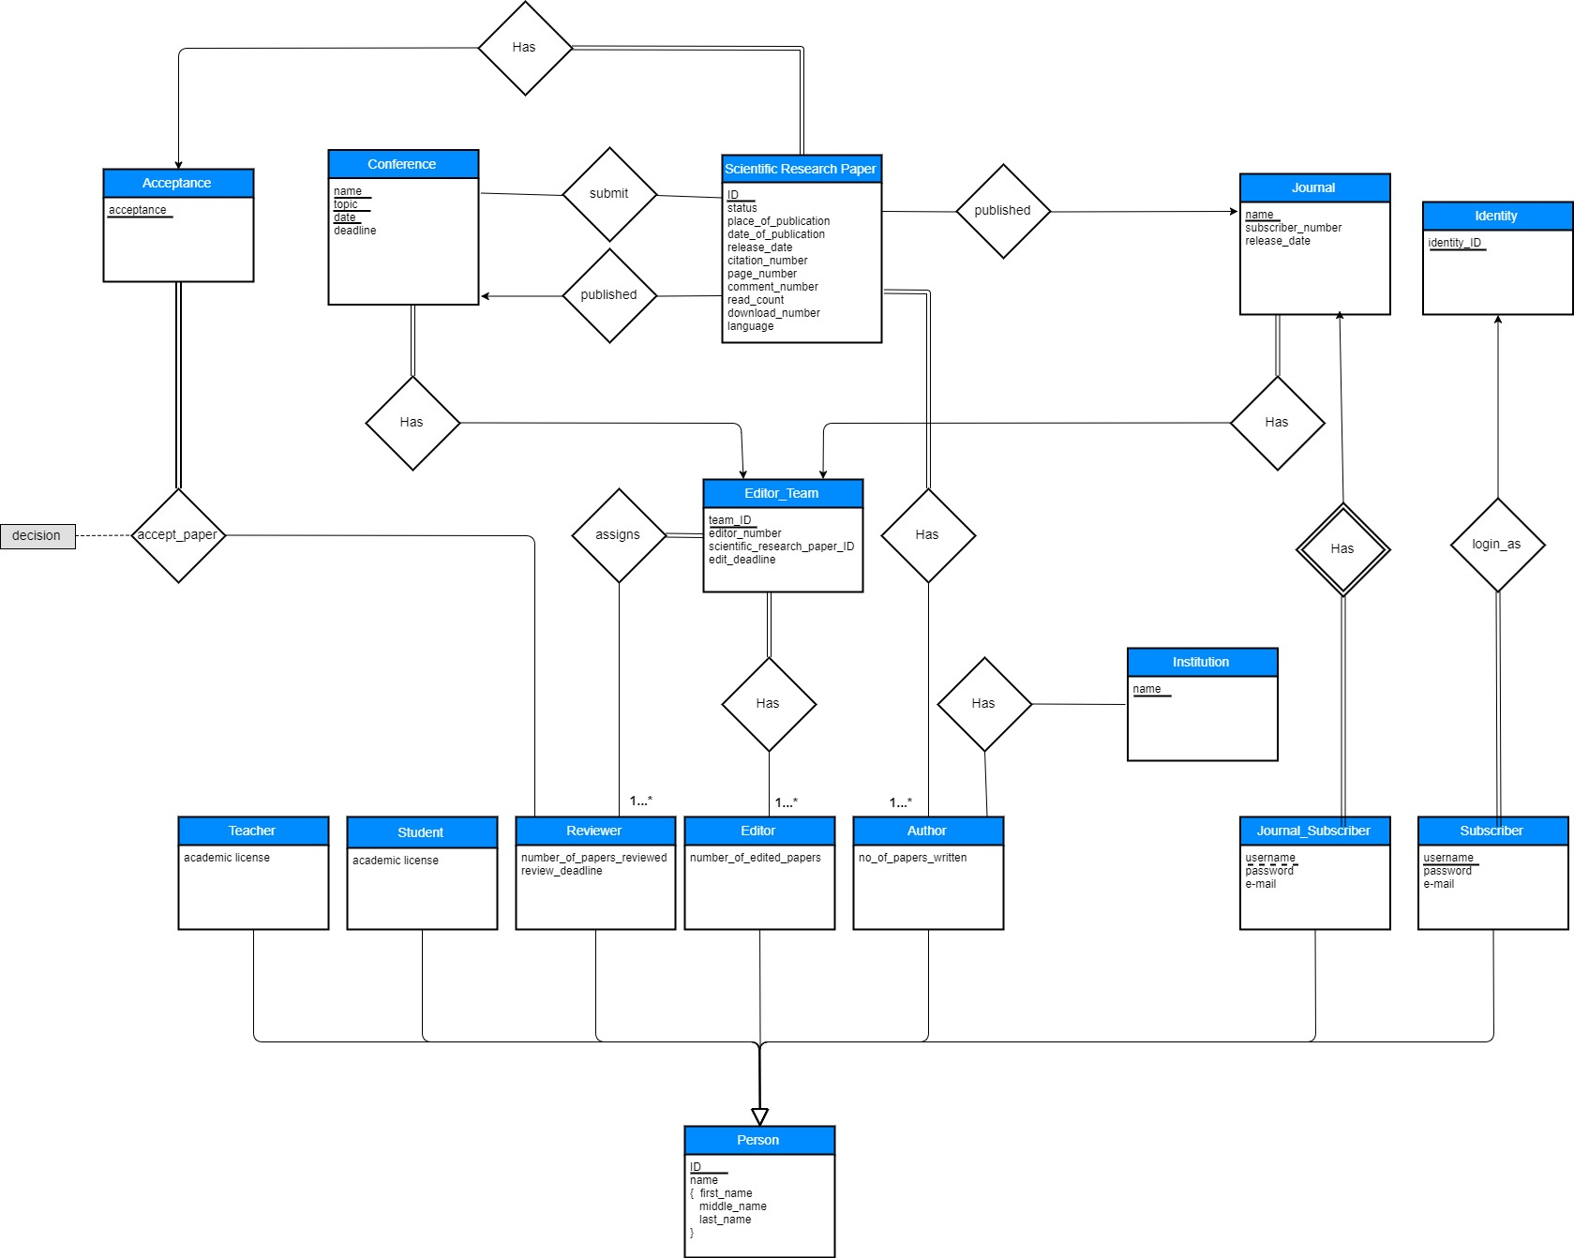

**6. CONCLUSION**

This project is a library management system that is inspired from the ACM and Bilkent Library Systems. In this system, people can search scientific paper with their names or author name, and add comment on this scientific paper. They also see the paper’s publication date, place, citation number, page number, released date, read count, download number. Our system aims at design a useful library management system that searches scientific papers in a detailed manner.

In this proposal, it is clarified how the implementation will be done, how parts of the project will be used and why parts are taken into consideration as separately and why they are not an attribute. These decisions are important for the further implementation because difficult parts of the project which we will deal with are indicated in this report. Additionally, non-functional requirements and limitations are indicated.

**Website:**

The wiki page, where all the information about the project is available is:

<https://github.com/hlarik/CS353_Spring18>